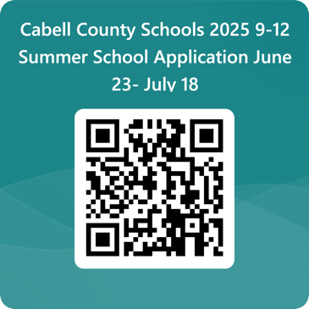**Registration:**

* You can register online at <https://forms.office.com/r/19tRqw2V0y>

OR by using the QR code.

* You can also register at HHS on Friday, June 23 in the cafeteria at 12:30 pm.

**Schedule:**

**Senior Summer School** (For seniors only)

* + June 5 – June 19 **at HHS**
  + Students will attend Monday through Friday 8am-3pm. Breakfast & Lunch will be provided.

**Traditional Summer School** (Grades 9-12)

o June 24 - July 18 **at HEMS**

* + Students will attend Monday through Friday 7:45am-2pm. Breakfast & Lunch will be provided.

**Transportation:**

* A limited number of buses will run during traditional summer school only. Bus routes will be available on the cabellschools.com website before summer school starts.

**Instruction/Technology:**

* All summer school course work is completed through the online program, Edgenuity.
* Students are *required* to bring their MacBook and charger to summer school to participate.

*For more information concerning Cabell County Summer School Program please see the registration form.*